
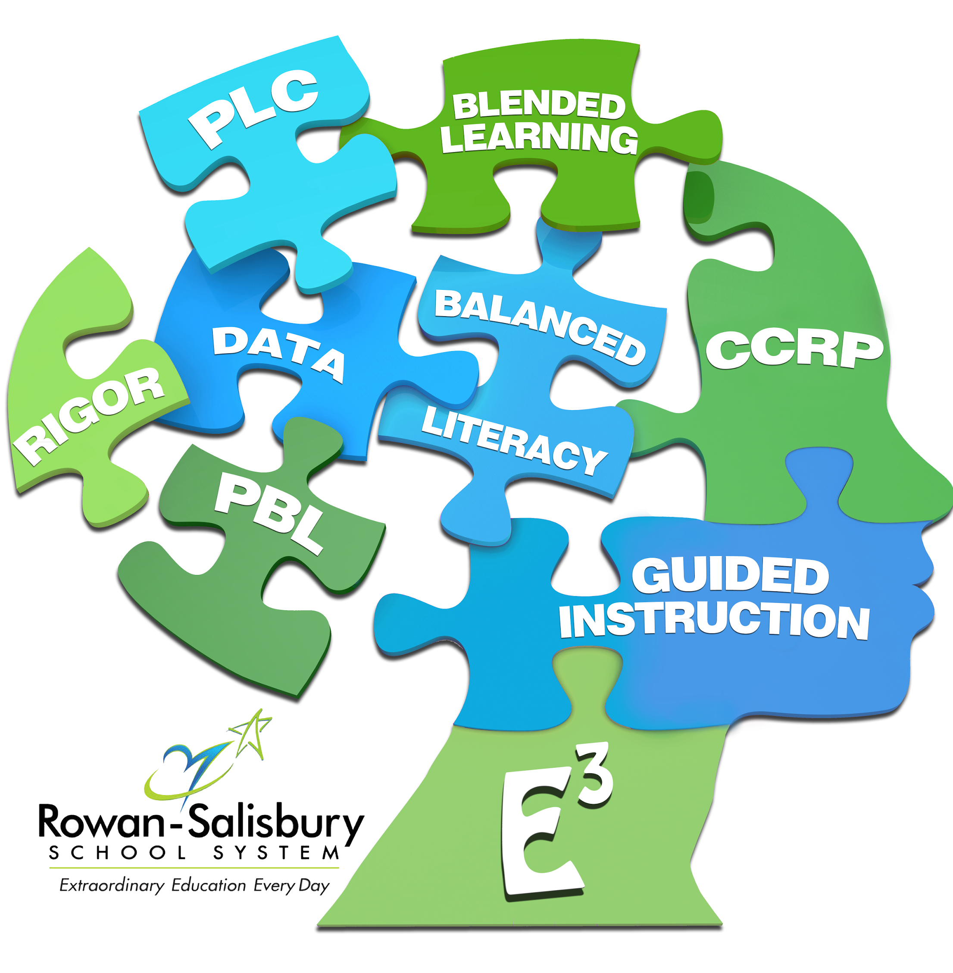
Ms. Clay’s BIOLOGY SYLLABUS

The Biology curriculum is designed to deepen understandings of concepts from previous learning at a more abstract level. In-depth study of the following concepts is included: the cell, the molecular basis of heredity, biological evolution, the interdependence of organisms, matter, energy and organization in living systems, and the adaptive responses of organisms. Students will investigate biological concepts through various lessons and laboratory activities.

HONORS: This course is designed to both challenge and encourage students to learn beyond the standard course of study objectives that are set by the state of North Carolina. Through additional projects, essay writings, class discussions, and collaborative work.

At the end of this course, you will understand:
- The Structure and Functions of Living Organisms (Bio.1.1-1.2)
- Ecosystems (Bio.2.1-2.2)
- Evolution and Genetics (Bio.3.1-3.5)
- Molecular biology (Bio.4.1-4.2)

NC Biology Essential Standards

NEEDS AND RESOURCES

Required Materials

To successfully complete this course, you will need
- Laptop
- 1- composition Notebook
- 1- 1 subject notebook (used only for BIOLOGY)
- 2- 100 count index cards
- Pens/ Pencils
- $10 Science lab fee

Online Resources
- Schoology- https://rss.schoology.com/
  - Username: last name, first initial, middle initial, last 3 of Student ID (i.e. doejc###)
  - Password: Student ID #
- Discovery Education- https://rss.discoveryeducation.com/
  - Login with Schoology username and password
- Achieve 3000- http://www.rss.k12.nc.us
  - Click “Staff”
  - Login with Schoology username and password
- Gmail Account & Google Drive
  - Email address: username@rssed.org
  - Password: Student ID #

COURSE SCHEDULE

UNITS: | # Of DAYS:
1- Cells | 7
2- Organic Molecules & Enzymes | 7
3- Cell Energy | 6
4- Cell Transport | 5
5- Asexual Reproduction | 4
6- DNA & Protein Synthesis | 7
7- Sexual Reproduction & Genetics | 12
8- Biotechnology | 5
9- Evolution | 14
10- Ecosystems | 10

POLICIES AND PROCEDURES

General Rules:
Students are not allowed to use technology until instructed by myself. There will be no eating in class. Students should come prepared for class on a daily basis as well as being on time daily. Students are required to be courteous and respectful to the teacher and peers.

Grading Policies:
[The grading categories are as followed: Homework-20%, Quizzes-20%, Project- 20% and test are worth 40% of the overall grade in each quarter. Students have 3 days to complete any missing assignments including a test. After the 3rd day the missing assignments will no longer be accepted and the student will receive a zero for his/her missing assingnment(s).

GRADING SCALE AND POLICIES
Grading Scale:
[10 point NC grading scale.] Grading categories are listed below and equal 100% for each quarter.

A: 90-100  B: 80-89  C: 70-79  D: 60-69 | Homework: 20%  Quiz: 20%  Test: 40%  Project: 20%

ADDITIONAL INFORMATION

My name is Brittany Clay and this is my 2nd year teaching Biology at North Rowan High School. I received my Bachelor of Science in Biology from Johnson C. Smith University in 2012. After receiving my B.S., I furthered my education at North Carolina A&T State University receiving a Master in the Art of Teaching- Biology Education in the fall of 2014. During this semester I will ensure that learning is taking place and students will be prepared for their NC EOC Biology exam.

CONTACT INFORMATION

- [Ms. Brittany Clay]
- [704-636-4420, ext 376120]
- [Brittany.clay@rss.k12.nc.us]
- [Classroom Number- A20]

Student Signature: _____________________________________ Date: ______

Parent Signature: _____________________________________ Date: ______

